Grade 4 Supply List

Please bring these items to school on the first day:

- Two white 1” hardcover binders with pockets in the front and back. Please purchase one with the clear plastic covering on the front.
- One wide ruled marbled composition notebook (not spiral bound)
- One box of 12 colored pencils
- Two boxes of pencils, sharpened (no mechanical pencils, please)
- One handheld pencil sharpener
- Four Expo white board markers
- Two erasers
- Two glue sticks
- One pack of Post-It sticky notes (3” x 3”)

- One pencil pouch that will hold the above items (except binders and notebooks). Pencil boxes do not fit well in desks with binders, books, and notebooks.

- One container of “eco friendly” cleaning wipes
- Two boxes of tissues
- Optional: Lightweight Portable Headphones for computer work (store in labeled plastic bag)

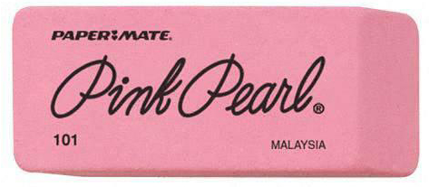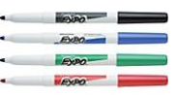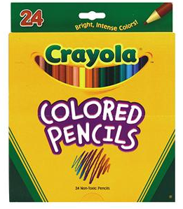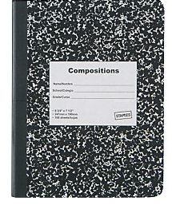

Thank you all,
Fourth Grade Team

